Game proposal
Game title
Llama Drama
Genre
Story-driven, defence puzzler with hints of a sandbox
Overview of game
The game revolves around a lone robot who has been working day in and out of an accounting office for over a hundred years just trying to do its job. As the days go on within the working week, they find out not everything is as desolate as it seems, and they are no longer alone.
Backstory
In 2019 when scientists were trying to find a covid cure they realized that llamas had a unique antibody that made them immune to covid. Shortly after, in 2023, they continued to test on llamas because they believed if they could cure covid using their antibodies, they could possibly prevent other diseases. They kept testing after the pandemic cleared. Unfortunately, over time the llamas began to show physical mutations due to excessive testing. What the government thought they could control would then turn into a revolution due to the revenge plan lead by the Dall-E llama, a newly elected political llama figure with enhanced intellect. For the next 30 years the humans fought for survival, but they all eventually perished. In 2100 with no humans left, the only remains of the androgynous species were the counterparts they created, such as working robots, facilitated in different job fields. It’s a post-apocalyptic world set in the year 2237, in which this particular robot is in an accounting firm, and works day in and out tirelessly until one day a miniature mutated llama appears and decides it wants the robot out…
Objective
The objective of the game is to complete all your tasks in the office without failing or being sabotaged by the llama three times. If you’re unsuccessful, the day will end regardless of the state the tasks are in. The reason why is that this will affect your company’s profits due to the work you might not get done.
Gameplay
The game will have a day system. This is where the player will play through multiple days in the same area. There will be a few days but the first day will be a type of tutorial which will teach the player how to do their job right. The second is where the llama begins to aggravate the player, and then it starts getting interesting from then. The player will be doing tasks around the office each day. If they fail three tasks or the llama disrupts three tasks, then the day will end. If the player doesn’t complete everything that day, there will be repercussions. You’ll get credit for the tasks you did right during the day. After the day you get your results in the form of a table. The table will say: the tasks you did/didn’t do, if you did them to company standard, and reasoning why it was accomplished/not. You will be deducted credit if you don’t complete a task when the day ends. The money will allow the player to unlock décor around the office. The player can also go to the kitchen to buy traps and weapons to stop the llama - a mouse trap - or repair items/tasks the llama breaks - replacing the wire for the printer the llama could chew.
Floorplan
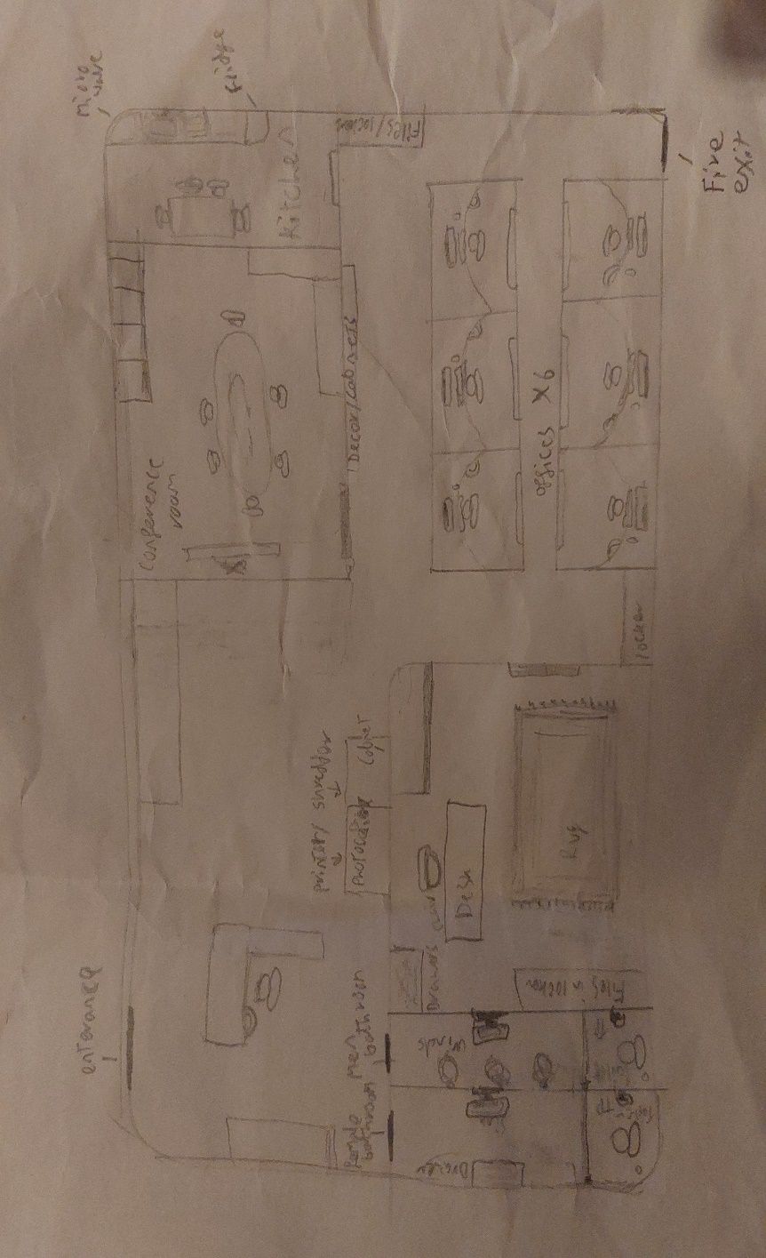
This is the floor plan of the office.
Areas and assets:
Bathroom: 1x toilet, toilet paper, 1x mirror, storage.
Conference room: 1x oval table, 8-10x swivel chairs, 1x projector/whiteboard, 1x remote/whiteboard pens, 2x plants, 1x clock, lights, windows (natural lighting), window blinds.
Offices for workers (per room): 1x desk, 1x small plant, personal items, 1x letter/notice board, 1x chair, 1x desk fan, 1x stationary kit, 1x trash can, 1x printer, 1x computer tower, 1x computer screen, 1x mouse, 1x keyboard.
Boss office: 1x big desk, 1x podium with a prized possession on it, paintings, 1x carpet, 1x bigger chair, 1x phone, storage cabinets, 1x small plant, 2x big plants, personal items, 1x desk fan, 1x trash can, 1x printer, 1x computer tower, 1x computer screen, 1x mouse, 1x keyboard.
Reception area: 1x photocopier/printer, 1x shredder, 1x corner desk, storage cabinets, 1x phone, 1x clock, 1x metronome/newtons cradle, 1x keyboard, 1x mouse, 1x chair, personal items, 1x stationery kit, sticky notes, 1x computer screen, 1x computer tower, 1x couch nearby for waiting area.
Kitchen: 1x microwave, 1x fridge, 4x chairs, 1x table, 1x sink, 1x dishwasher, 1x bin, 1x kettle, sugar/coffee/tea, cupboards, item fabricator.
Non-room defined areas (hallways, areas for lockers, etc.): storage lockers, 1x shredder, 1x photocopier, bins, employee of the month area, general décor, cabinets.
Mechanics
Day flow:
The first day will be challenges that introduce the character to their day-to-day tasks. The second day of tasks will be more of an in-depth day on how to survive the llama attacks. Day three things ease up as you choose the end to the story: freedom ending or survival mode.
Point tally menu:
. 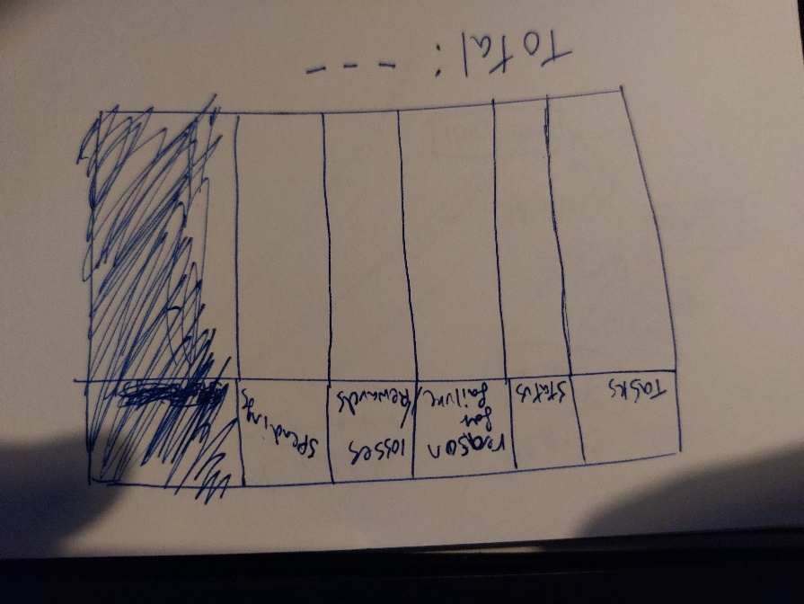
The player will get a table between games to show them what happened. This will say what they did, if they did it well, what they spent, and how much money they lost.
Money:
We drew a symbol for the credits
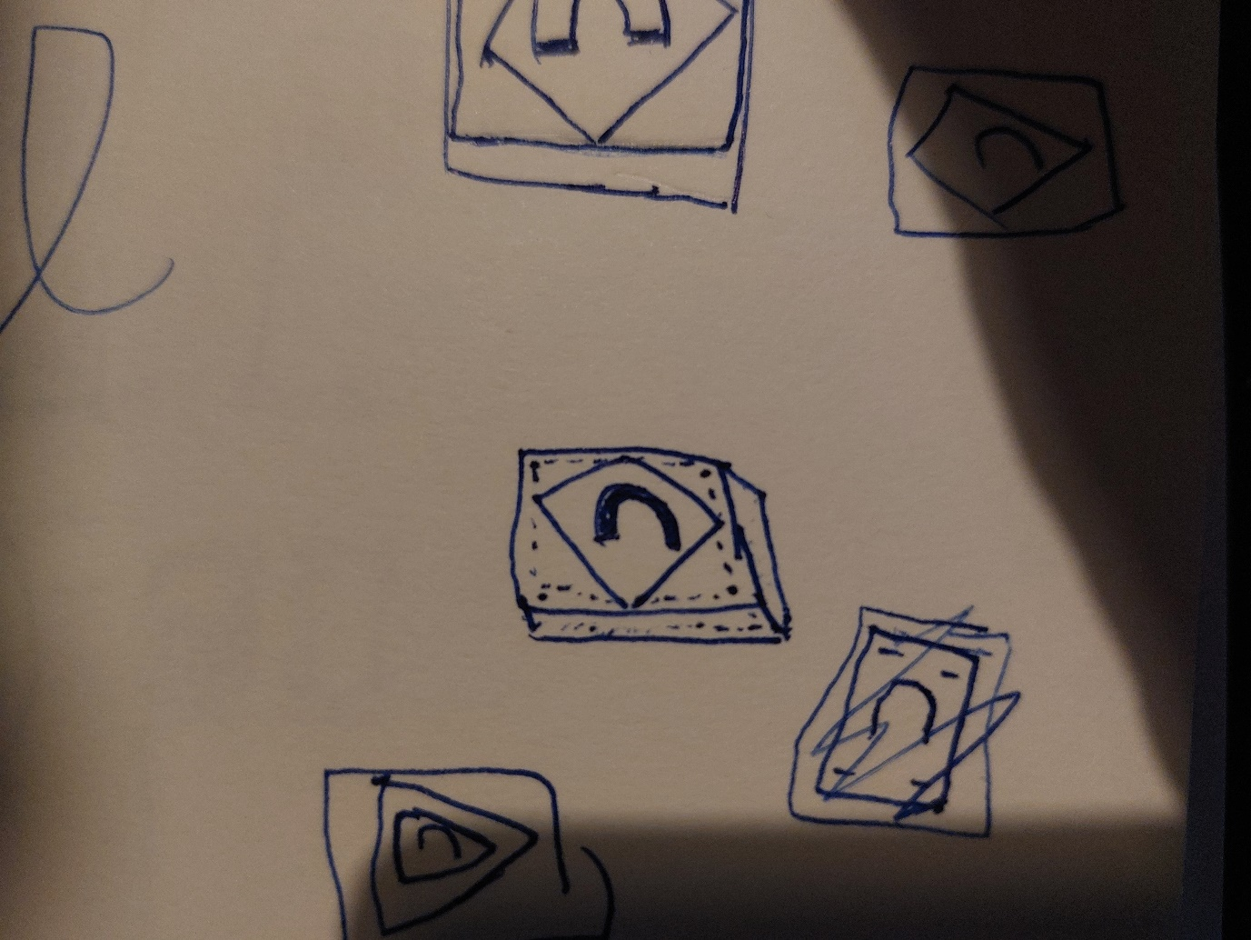
After the first day (tutorial day), the player will be awarded 150 credits to begin. The next day they can spend the money on the fabricator’s items.
If the player completes all tasks during the second day, they will get 200 credits. For each task the player doesn’t do they will get -30 in credits after the day has passed for day three.
Day three won’t have the llama trying to stop you. There will be two endings. The first being the freedom ending, so money won’t matter here. The second being survival mode, so the money earnt from day three doesn’t get added as day three is more story-oriented, but they’d still have the money from day two.
Player:
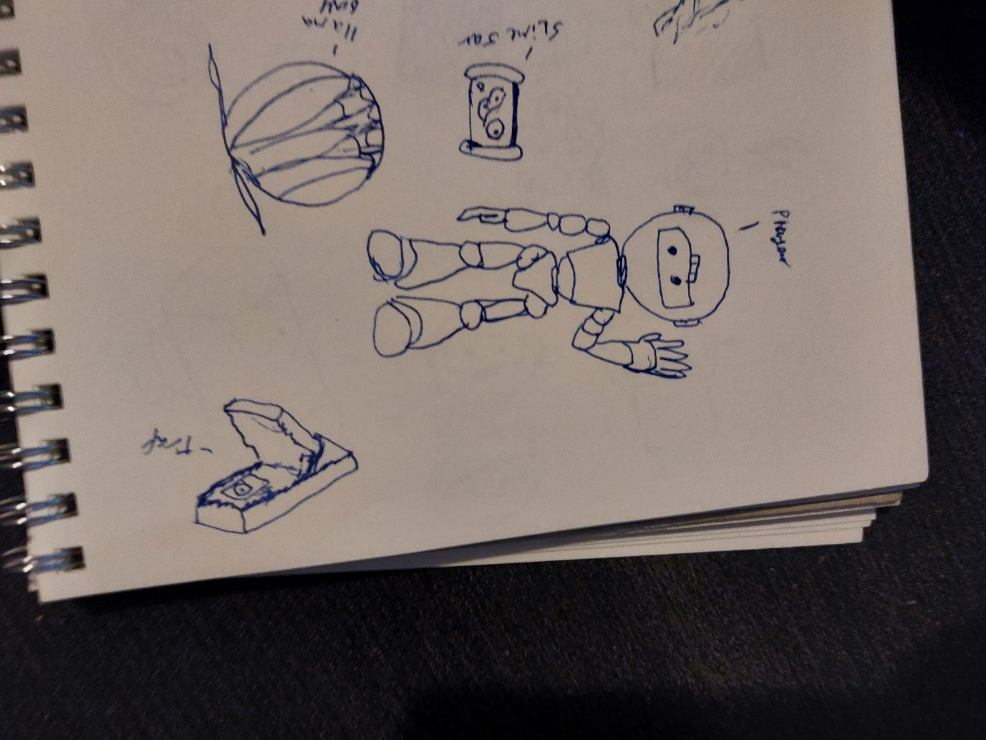
- Can pick up all office items
- Can teleport
- Can use the credit to buy items from fabricators
- Can do tasks around the office
- Can repair broken objects with repair items
- Can trap the llama with trap items
- Can hit the llama with objects
Llama:
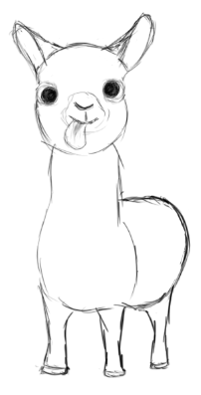
- The llama can disrupt challenges
- The llama can walk on the walls and ceiling due to genetic mutation in their hooves
- The llama can also break tools/traps if it has been stopped by that trap before on the day
- The llama can travel through ventilation in the office for faster movement/gameplay
The llama uses a state machine. The state machine will have four states:
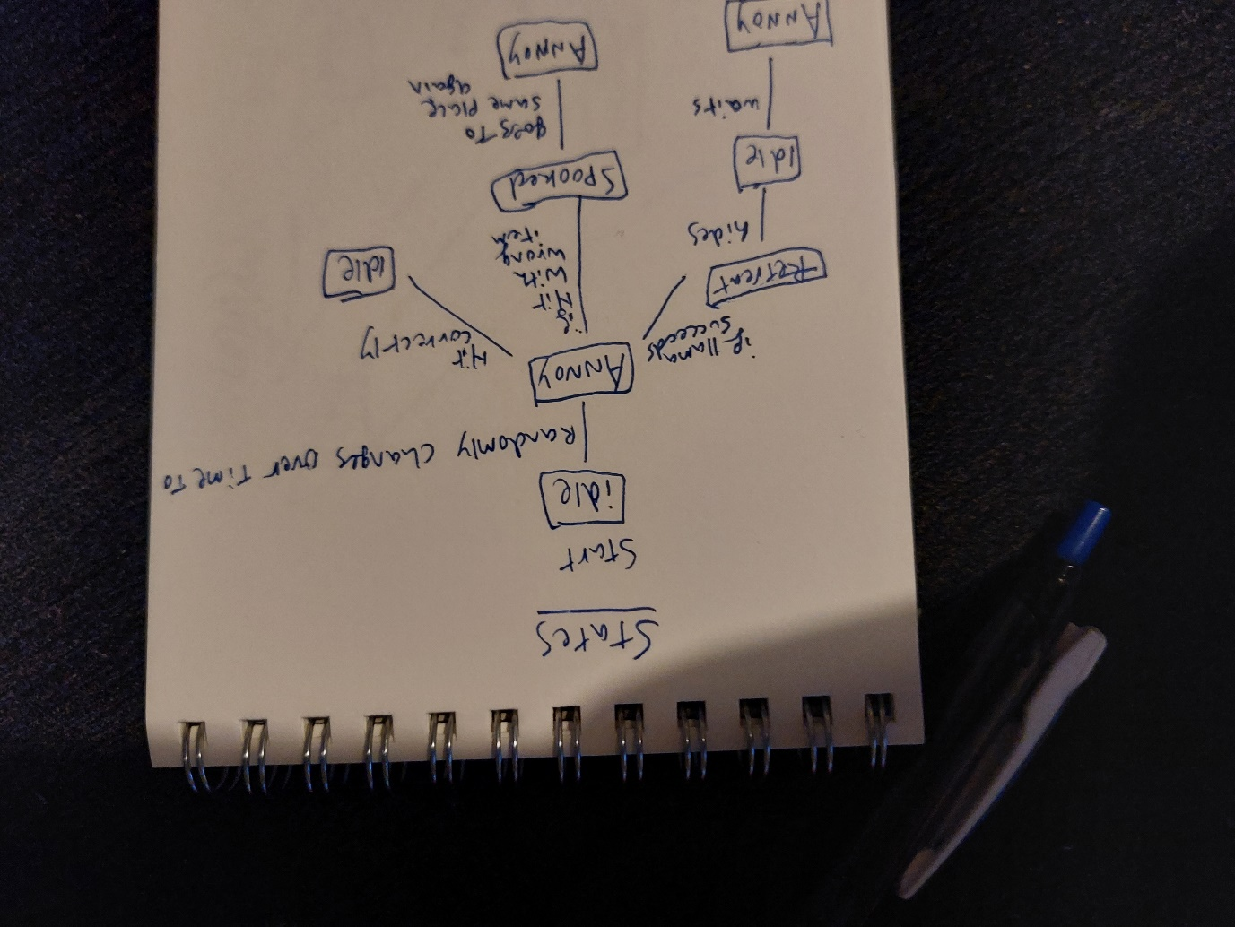
Annoying state:
The llama will randomize a task to attack and attack it.
Retreat state:
The llama succeeds in an attack and runs away. Once hidden, the llama state will change to idle.
Idle state:
The llama in this state just bides its time out of sight. Once it randomizes a task and time frame to attack it changes to the annoying state.
If the player or llama completes their objective, the state changes to idle.
If the player hits the llama with an object designed for llama control or damage, the llama will return to an idle state and won’t pursue that objective again.
Spooked state:
When the player throws an object which isn’t designed for llama control, the llama will leave temporarily and try to attack the same area again soon. This would occur when the player throws an object not produced by the fabricator at the llama.
Fabricator:
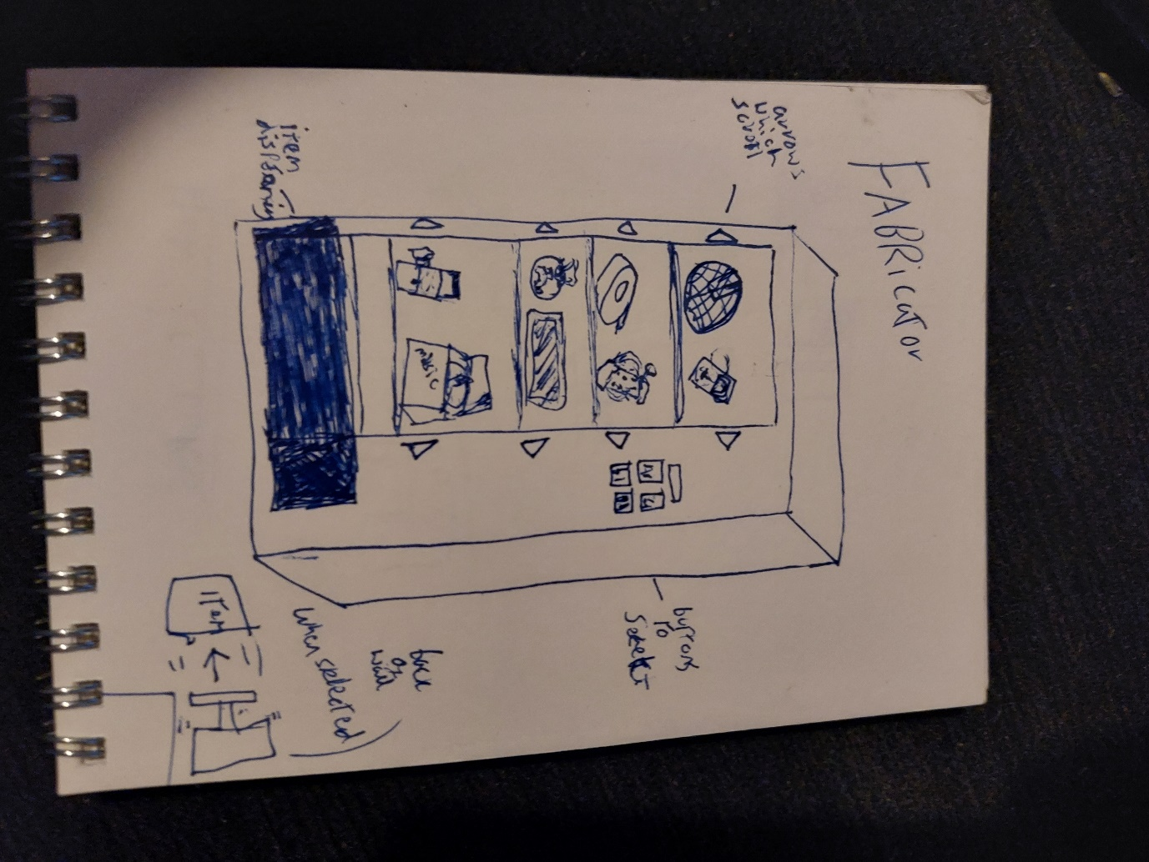
In the fabricator, there will be four types of items you can get: preventative/repair items, trap items, repelling items, and detection items.

When the player uses the fabricator, the object they purchase will be pushed off the shelf within the machine by a piston on the back wall. The player will then pick the object up from the compartment below and the object will then materialize over time if it can be used multiple times. The cost will come out of the player’s overall funds.

Preventative/Repair items: Will help the player repair tasks the llama has broken or will stop the llama from breaking them, which will allow the player to complete their tasks. The only one of these items you can move is bubble wrap.

Item 1: Duct tape. Used to fix various things around the game, such as broken objects or chewed-up cables. If a cable is duct taped the llama can no longer bite the wire. One-time use per buy. Cost: 20 credits

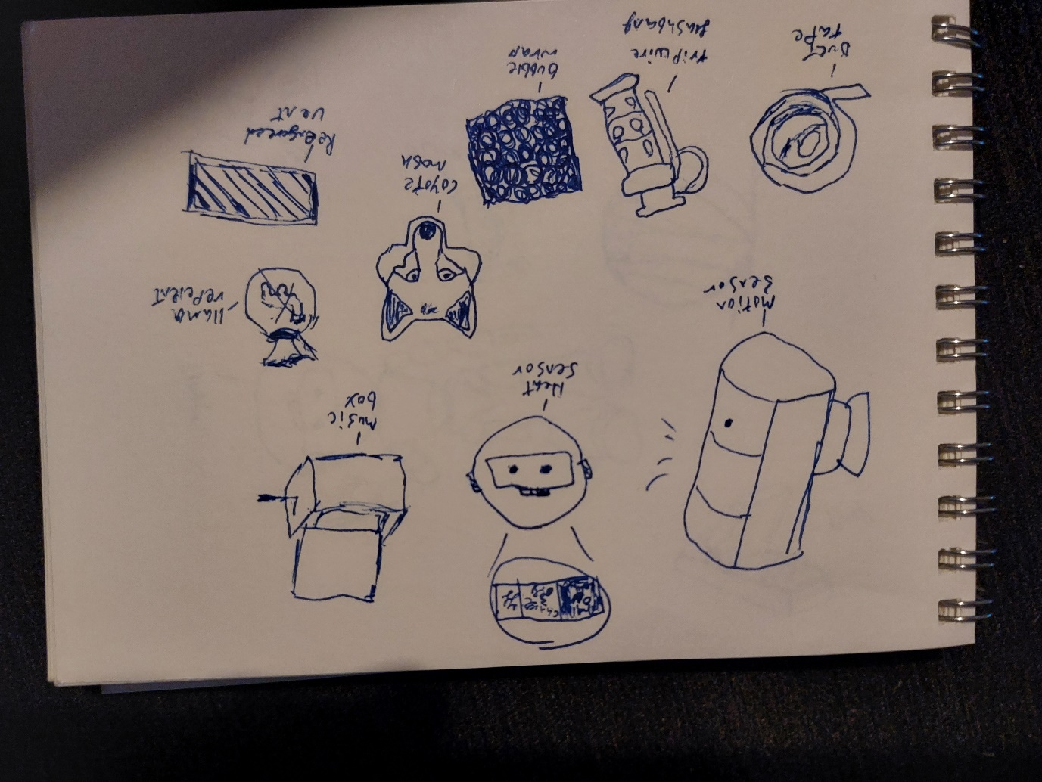

Item 2: Bubble wrap. Can be placed in rooms to stop the llama from breaking items. This will affect the cleaning task as if the llama does break something it will take longer to clean, wasting your time. One-time usage per buy. Cost: 15 credits
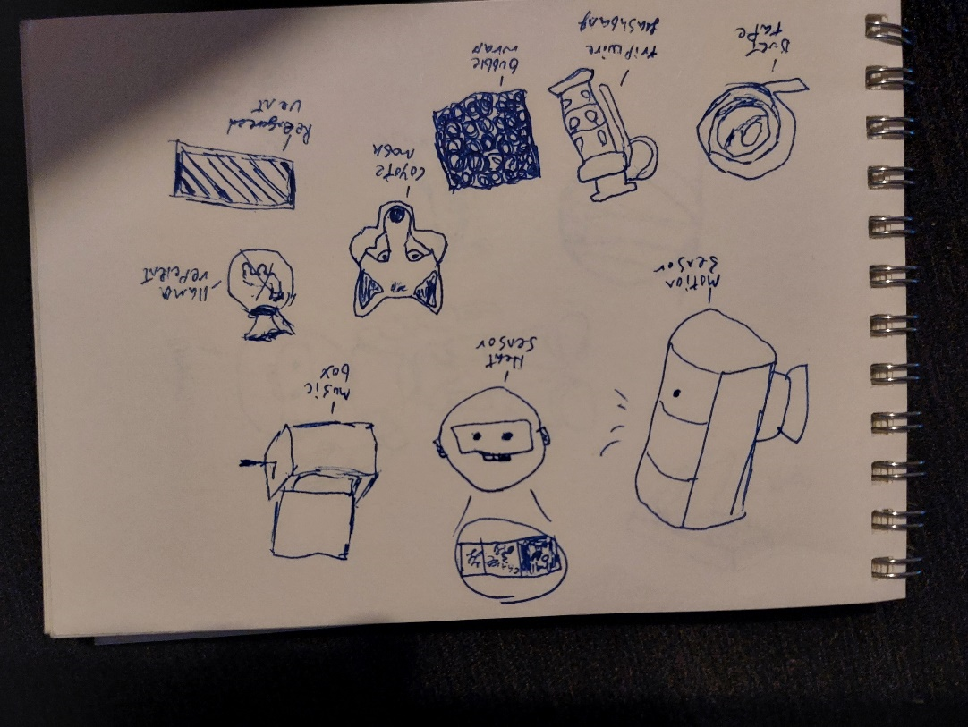
Item 3: Tripwire flashbang. The player can put this on the wall and a laser will hit the wall opposite. If the llama passes through this laser, the flashbang will go off and the llama will be stunned for a moment. The player will hear the noise and the llama will go into the spooked state, allowing the player to prepare a fast counter to the attack. One-time use. Cost: 40 credits
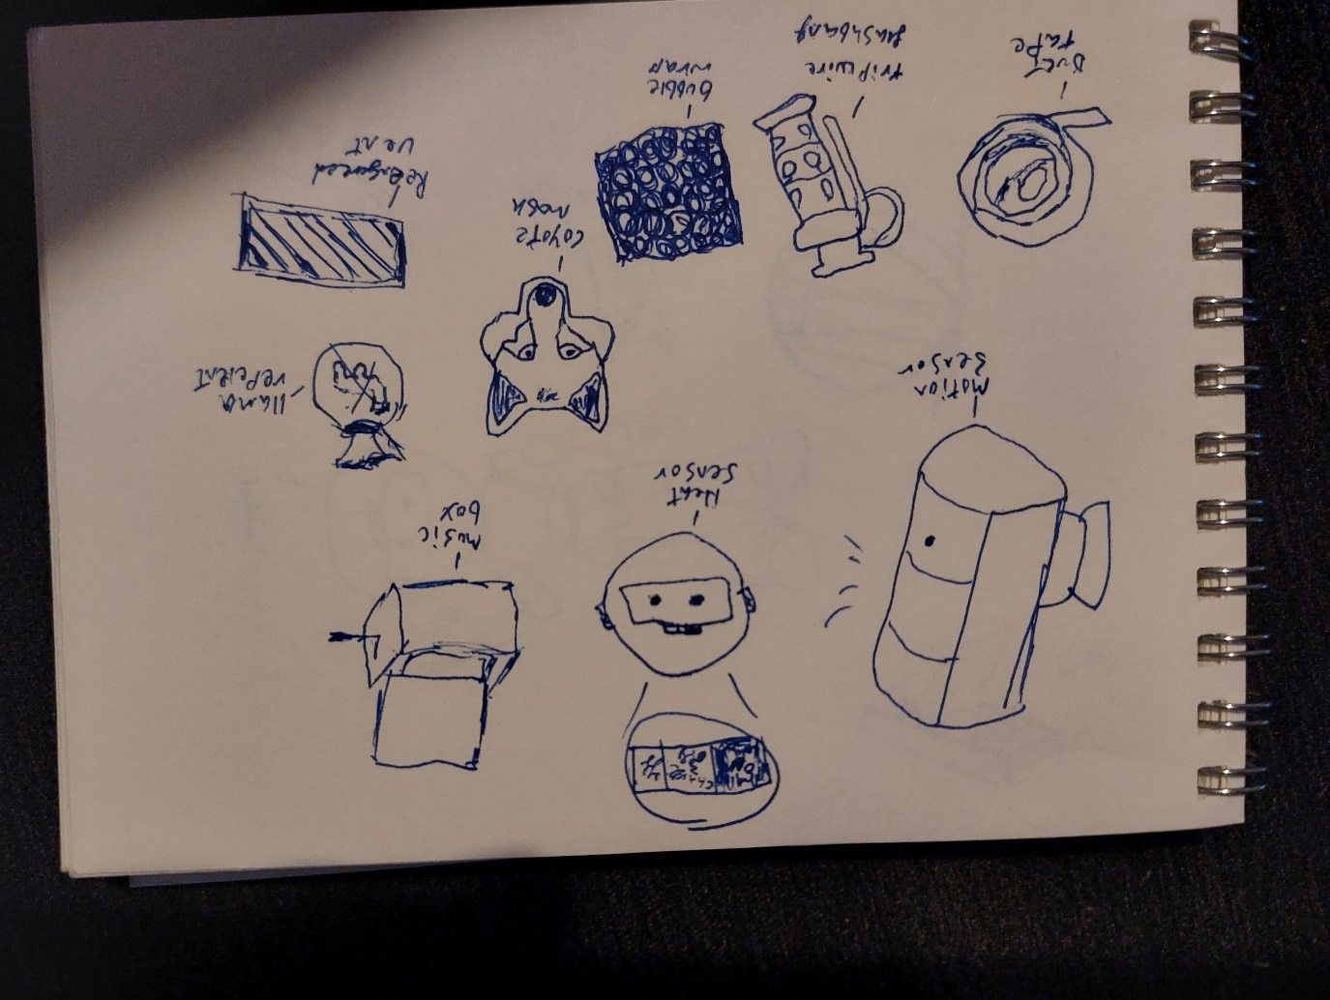
Trap items: Will prevent the llama from getting to or breaking a task. The only trap which cannot be picked up once put down is the slime trap.

Item 1: Llama cage. This is a hamster ball-type cage which will trap the llama inside for 20 seconds should it wonder onto the trap. The player can throw the trap around once the subject is captured. Once the llama is released, it will change to the idle state. One-time use. Cost: 30 credits

Item 2: Slime trap. Place this slime on a surface to make the llama go slower when they walk through it. If the llama steps through, it continues to attack but you can hear the sound it makes as it slowly moves. One-time use. Cost: 20 credits
Item 3: Mouse trap. The player can place mouse traps to try to stop the llama from interfering. If the llama is hit by the mousetrap it will change to the idle state. One-time use. Cost: 30 credits
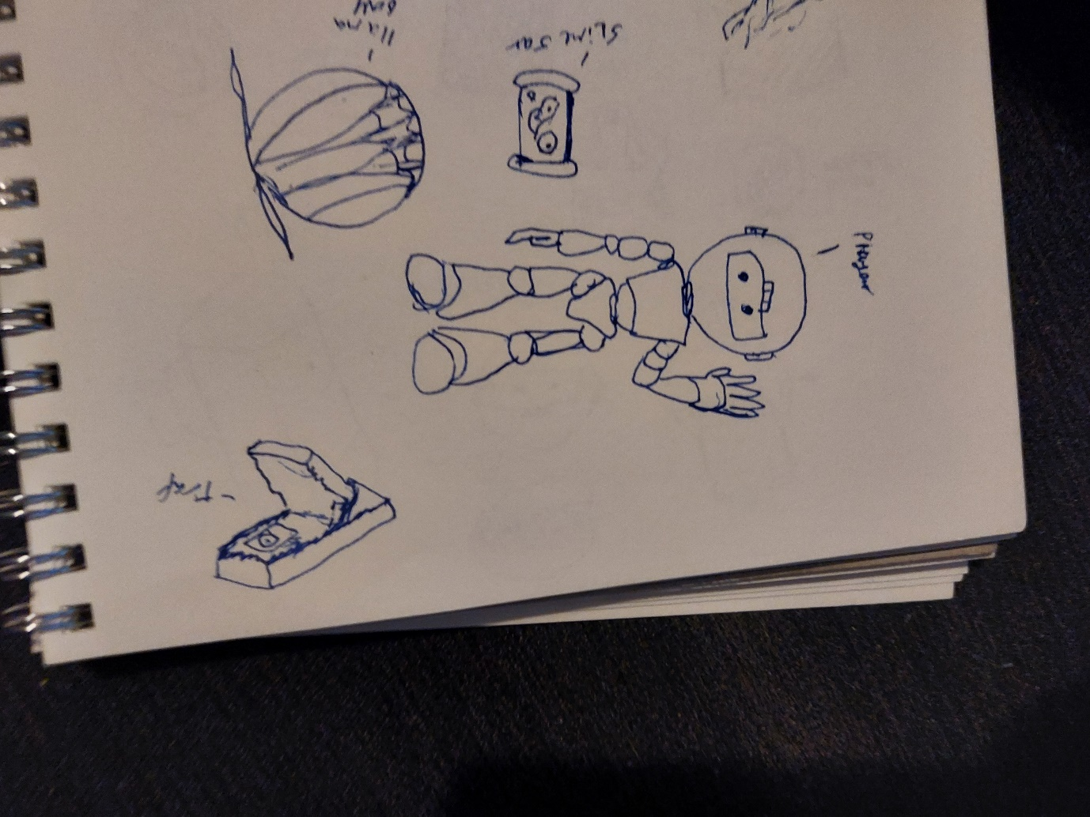
Repelling items: Will help you lock down areas or prevent access temporarily for the llama.

Item 1: Llama repellent. Spray in an area and it will make the llama ignore that area for 30 seconds. If you spray this while the llama is in the area, then the llama will go into the idle state. One-time use. Cost: 40 credits
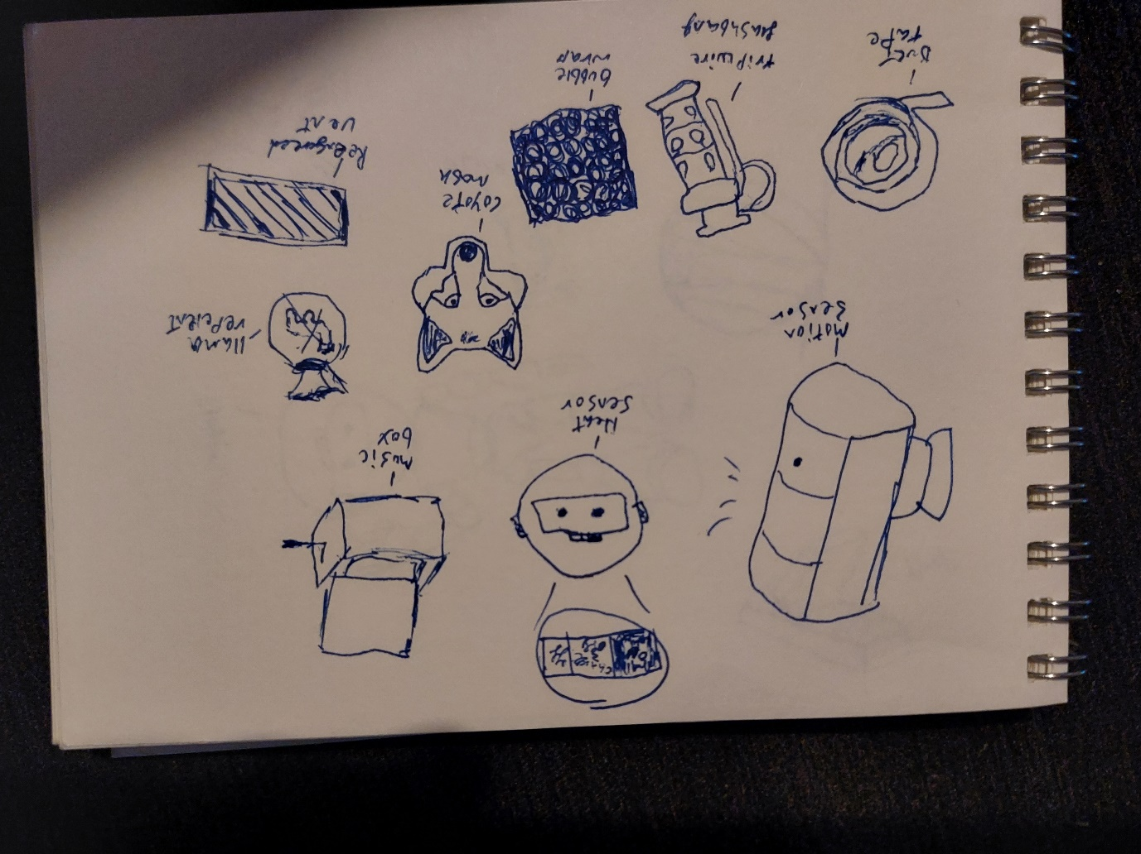
Item 2: Reinforced vent covers. As the llama uses the vents to move around, the player can buy improved covers which take the llama some effort to break through. This will restrict the llama and tell the player via audio when they are breaking the vent. The vent will have 5 hit points. If the llama breaks the cover, they proceed to attack the task they’re near to. If the player hears this and finds the llama breaking it down, they can remove the cover, revealing the llama, which makes the llama go to the idle state. The player can then place it back down, but the % of health won’t change on the object (so if the llama has hit the vent 3 times and it has 5 max hit points, when you put that vent back down it will have two hit points left). One-time use. Cost: 30 credits
Item 3: Coyote mask. Llamas fear coyotes so you can now fabricate a coyote mask and place it inside a room (max 3 per day). If the llama sees the coyote in one of the rooms, they will go into the spooked state. The llama will return once realizing it wasn’t real. One-time use. Cost: 30 credits
Detection items: Will detect the location of the llama for the player. All detection items can be moved except the music box as it is used instantly.
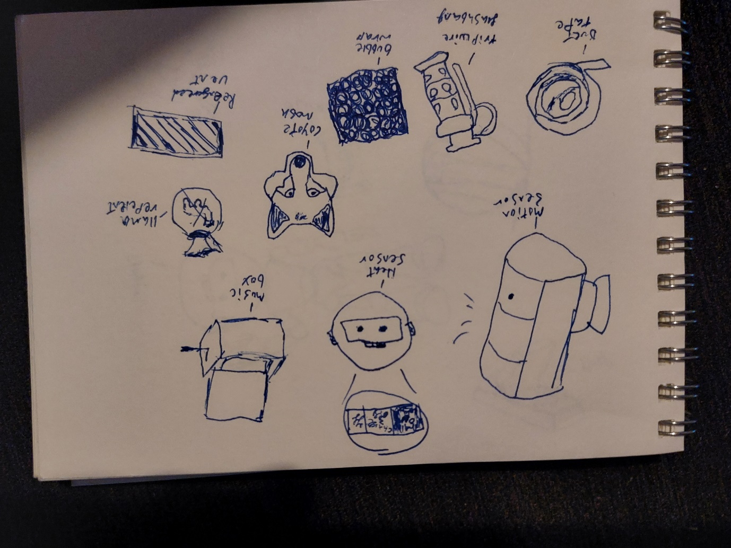
Item 1: Heat sensor. The player can buy charges for a minimap (the robots' built-in heat sensor). When the player pushes a button, a minimap will roughly show the location of the llama for 6 seconds. One-time use (max 3). Cost: 20 credits
Item 2: Music box. The player can place down this box which plays sound to draw the llama in (max 3). Once in range of the object, the llama will head to see where it is and break it. Can’t be moved. If the player places this box while the llama is there, it will take 20 seconds to break. Once the llama has broken it the llama will go into the annoying state somewhere else. Cost: 30 credits
Item 3: Motion detector. The player can place down a sensor that will beep loudly if the llama is passing by (max 2). If the beeping starts and the player doesn’t hit the llama in time, the llama can spit at the sensor, destroying it. Can be moved. Cost: 40 credits

Day-by-day tasks:
**Day 1 **
(The first day will have more Linear tasks to introduce the player to the gruelling tasks of a normal day).
On day one you can't fail tasks as there isn't a llama or a time mechanic. Day one will mainly be used as a tutorial.
The first task is to sign into work. When you get to work the game will instruct you to sign in before each day will begin, so this is the first task naturally. The next task is to sign/review your NDA. The player then needs to go to their desk and update their company NDA.
Once the player has done that, they need to approve and reject applications for business funding. The player will get a few business proposals (around 5-10). The player needs to reject or approve the relevant applications. Get 3 out of 5 successful applications approved by the corporation to succeed in this task.
After that the player will be required to clean up. Areas around the office will be messy so tidy up the areas to complete this task. Finally, the player is asked to sign out as it symbolises the robot coming off their shift. At the end of each day, you need to sign out as it shows your comings and goings.
**Day 2 **
Day two will have more of an urgency to the day. The first part of the day is where the player will need to complete all the tasks they have active, and purchase items from the fabricator to stop the llama from sabotaging them. There will be a break period to help set up more defences or explore, then after the grace period the working part of the day will start again with new areas to work at and defend.
At the start of day two you go to sign in and find the pen is missing. The player is instructed to “find or buy” a new pen, so they can either buy the pen from the fabricator in the kitchen (introduces the fabricator) or locate where the llama has put the pen.
After the player has signed in successfully, they hear a loud noise and are instructed to go investigate. When they arrive, they find the llama in the process of breaking the boss’ prized possession. The llama breaking the object sets off the failsafe alarm in the office and a pre-recorded message will tell the player off. Meanwhile the llama has escaped the room via the vents. In the voice memo, you are instructed to clean up the mess so you can either bin the shattered object or repair it with duct tape for bonus points at the end of the day.
Once the player leaves the bosses office, they need to get back to work. This is the part of the game where the player will be asked to do multiple challenges within a time frame and will need to complete them before the time ends. The llama will be roaming during this time so the player will need to stop them from interfering.
Now the player has been introduced to the fabricator, they can purchase items. Generally, you can use all the detection items around the map wherever you want as they help you find the location of the llama. You can move all the detection objects except the music box as it is used instantly. All repelling items from the fabricator can be used in all rooms. The only exception is the reinforced vent covers. You cannot use the vent covers in rooms without vents, such as the workers' office booths. You can only move one repelling item which is the reinforced vent. The vent is only moveable when the llama is caught on the other side trying to break it. The trap items can also be used in every room. The only trap item you can't move after placing is the slime trap. Once a trap is used, the trap will either break or disappear. The last items you can get from the fabricator are the preventative/repair items. The only repair item which can move is the bubble wrap, so you can protect the items the llama drop easier.
One of the tasks will be to use the photocopier. In this task the player needs to bring a document to the photocopier, put it in the copier and wait a total of 30 seconds before collecting it again to succeed. If the llama interferes with the copier, they will remove the paper you used and replace it with its own to make llama copies of the paper. You will need to insert your paper again, which will make the copying process resume from where it left off (so if 20 seconds were done when the llama disrupted it, when the paper is replaced only 10 seconds left). This task takes time so if you don’t complete it within the time you fail, and if the llama completes 10 of their documents before you manage to do your own you will lose this task. The llama can also bite the cable stopping you from using the copier. The player will need to fix it with tape to finish the task. Ways to prevent this would be to set up a trap/detection or preventative item and pay close attention to audio cues which tell you about the llama's location.
Another task would be the approve and reject applications task that was on day one, only this time if the llama destroys 3 of the “successful business applications” you will fail the task. Out of the 10, only 5 sheets of paper are successful. Get 3 out of 5 successfully approved to corporate to succeed. The llama can hide the applications around the room too, so the player could fail via time. Once again, you can use all the items in this challenge.
In the task clean up, the player has a prompt to tidy each room. If there is an overall percentage of 25% untidied by the end of the day, the player will fail this task. To win, tidy up rooms as you go along. The llama can still mess things up even if you have tidied all areas. This is an ongoing task so it can only be completed by waiting out the timer for the break. If any more than 25% is messy, the llama wins the task. For this task, the most useful item is bubble wrap because it stops more damage from accumulating. All items can be used on this task as it's around the whole office.
The player then has mandatory break time after those tasks and can prepare for the next half of the day. They can set up traps or just explore the scene for a minute or two.
Again, one of the tasks you need to do is approve and reject applications. This is to show that mostly you just do similar jobs at work. Get 3 out of 5 successfully approved to corporate before the timer expires or the llama destroys 3 successful business proposals. The clean-up task will be active here again too as once again, it is an ongoing task throughout the workday.
After lunch, your colleagues require coffee so you will need to serve coffee to the desks from the kitchen by carrying the coffee pot over and pouring it into the mugs. The first coffee will need to be made when you are in the kitchen. Boil the grounds on the counter in the coffee maker then serve (1 pot can serve 6). You succeed by filling all your co-workers’ cups (6 of them). You fail by not doing the task in time. The llama can drink the coffee, making the player need to replenish it. You will need to get more coffee grounds from the kitchen to make a fresh batch of coffee and serve again. To prevent the llama, you can use all the objects but the reinforced vents inside the workers' offices.
There will be a task to organize files. In this task the player will need to organize files that have been scattered around the office. If the llama gets a hold of a file, the player will need to chase the llama around the office and hit it with an object to get it to drop the item. Ways to prevent the llama from grabbing the items and wasting your time is to place traps which can slow, or repellent which stops the llama going near the area.
Before the end of the timer for work, the player is required to sign out before the end of the day (5 pm). Failure to do so will punish the player in the credit report after. After the day, the player will get the credit report sheet letting them know the income/spendings and tasks they didn’t accomplish.
**Day 3** (will include more linear tasks)
The llama writes a note for the player asking for freedom and the player sees this before signing in. The player will have two options for the rest of the day during tasks: do it the official way the characters' programming has been designed (office survival ending) or do what the llama wants (the freedom ending). The llama will be trying to convince the player to go along with its ideals during this day to try and deter them away from the office ending.
In the day there will be five tasks. If the player does 3 right, they get to stay in the office. If they rebel 3 times they can leave with the llama at the end in the last choice.
The first task will be signing in as usual; the player is given a choice to either sign in or break the clipboard. The player will head to the next task and read another note left by the llama. The next task is organizing files, so the player is given the option to either organize the files or throw them out the window.
The player has the approval and disapproval task this day so if they complete the task as they would normally, it’s a point for the office ending. If they decide to either fund everything/too many bad projects or fund nothing/too few good projects, it will count as the freedom ending.
Like before, the player will need to now give coffee to hard-working workmates. When this task is active here, they can either do the original task or give the llama coffee, which would support the freedom ending.
Then finally you can either sign out and get the office ending or find another way out to escape with the llama and get the freedom ending.
Endings
Freedom ending:
In the freedom ending the player and the llama both leave the office in search of adventure as new companions. The ending is activated when the player rebels on the last day.
Survival ending:
In the office ending the player will be put in a survival mode. To win they would need to survive for as many days as possible. To lose, just fail 3/5 tasks. The survival will get harder as the days progress, but the player will do tasks while being attacked by one or multiple llamas.

